System Requirements Statement (SRS) –

e-Mess System

Doc. Ref. : SRS_v0.4.doc

Version : 0.4

Status : Drafted

Created by : group 22

Date : 25-1-2021

1. Introduction 3

2. Functional Requirements 4

2.1 Consumer Module 5

2.2 Mess Owner Module 11

2.3 admin Module 17

2.4 message acknoeledgement Module 21

2.5 Use Case Diagram.............................................................................................................................22

THIS DOCUMENT CONTAINS 23 NUMBERED PAGES

# Introduction

This document explains the system requirements and scope for developing e-Mess System.

e-Mess System could divide the four main parts, Consumers part, Mess Owners part, Admin part and the acknowledgement part.

This document describes the system requirement of the Account part.

# Functional Requirements

The Account part of e-Mess System has three modules which are divided 13 processes described as below.

|  |  |  |
| --- | --- | --- |
| **No** | **BRS requirement ID** | **Description** |
| **2.1** | **Consumer Module** | |
| **2.1.1** | **F1** | **Account Creation Process** |
| **2.1.2** | **F2** | **Login Process** |
| **2.1.3** | **F3** | **Forgot Password Process** |
| **2.1.4** | **F4** | **Change Password Process** |
| **2.1.5** | **F5** | **Update Account Process** |
| **2.1.6** | **F6** | **Membership renewal process** |
| **2.1.7** | **F7** | **Filter out by Mess Categories** |
| **2.1.8** | **F8** | **Rating and review/comments** |
| **2.2** | **Mess Owners Module** | |
| **2.2.1** | **F9** | **Account Creation Process for itself and approval of members of mess** |
| **2.2.2** | **F9** | **Login Process** |
| **2.2.3** | **F10** | **Forgot Password Process** |
| **2.2.4** | **F11** | **Change Password Process** |
| **2.2.5** | **F12** | **Update Account Process** |
| **2.2.6** | **F13** | **update menus** |
| **2.2.7** | **F14** | **Browse existing Market reviews and rating** |
| **2.2.8** | **F15** | **Manage discount coupons** |
| **2.3 Admin Module** | | |
| **2.3.1** | **F16** | **Login Process** |
| **2.3.2** | **F17** | **Forgot Password Process** |
| **2.3.3** | **F18** | **Change Password Process** |
| **2.3.4** | **F19** | **Account Management** |
| **2.3.5** | **F20** | **Report Generation** |
| **2.4 Message Acknowledgement Module** | | |
| **2.4.1** | **F21** | **Sends Messages of Acknowledgement/notification (coupons/sp dish/membership exp)** |

## Consumers

* Consumer is the user of system who wants to ease their mess searching efforts.
* Consumers can used few facilities without registrations several times as Guest.
* He is also able to view the prices, menus at different messes using filters and can give ratings, reviews.

### Account Creation Process

* E-Mess System should provide the function which makes consumers creates new account to avail other facilities.
* When consumers creates new account, the function demands three information described as below.

1. Login information
2. Contact Details

* The Login information

The Login information consists of some items described as below.

1. User Name
2. Password
3. First Name
4. Last Name
5. D.O.B
6. E-mail address
   * All items are compulsory demanded.
   * User Name

* The User Name should be unique. If the User Name correspond with not case-sensitive to other which is previously registered, the User Name should not be registered as an account.
  + Password
* The Password has constrains which makes the Password consists of more than or equal 8 and less than or equal 16 characteristics including characters described as below.

1. Numeric figure (at least one)
2. Capital alphabet (A-Z)(at least one)
3. Small alphabet (a-z)(at least one)
4. Special character (#, $, %, &, etc.) (at least one)

* The Password is masked by dummy characters. The re-entering Password is demanded.
* The Password must be encrypted in e-Mess System.
* Contact Details
* The Contact Detail consists of some items described as below.

1. Current Address
2. Contact Mobile No
   * All items are compulsory demanded.
   * Current Address

* Current Address should be filled.
* But only the area should be selected from options.
* The Security Question information

The Security Question information is needed when consumer lost their Password. This information consists of two items described as below.

1. Selected Question
2. Answer
   * All items are compulsory demanded.
   * Some questions which are difficult to answer for anyone else are prepared in advance.

E.g. what is your nick name?

* + A question should be selected from options by the consumer, and the Answer is registered by the consumer.
* Login information should be entered on one screen, and then consumer information and Security Question information should be entered on another screen.
* *OTP via email/sms.

### Login Process

* The user authentication demands User Name and Password. The User Name and the Password should be checked in three ways.
  + First, the User Type linked to the User Name should be "consumer".
* When the User Type is "Consumer", then user can be placed on “Consumer Home”.
  + Second, The User Name and the Password should be existed and correct.
* If The User Name and the Password are not equal to what the user has registered, the user authentication cannot be provided.
  + Finally, User Name should be available. //ADMIN MODULE
* The Administrator can decide whether the User Name is available or suspended – Refer to the SRS of the Admin part.
* If consumer is rejected, user authentication is not provided for system user.
* Only when the three checks are successfully completed, consumer can be placed on respected page.
* The “Consumer Home” provides the some items described as below.

1. A trigger to logout
2. A trigger to update Account
3. A trigger to Change Password
4. A trigger to Search Area
5. A trigger to Update Profile
6. A trigger to Delete Profile

### Forgot Password Process

* When system user lost their Password, the recovery method should be provided by e-Mess system.

The recovery method is described as below.

* + First, system user enters their User Name for e-Mess System.
  + Next, E-Mess System demands the Answer which has been registered since when the Account was created.
  + Only when the Answer is correct, consumer get the new password by E-mail/SMS which also has been registered since when the Account was created.
  + The new password is automatically generated by e-Mess System.
* Of course, the new password should consist of more than or equal 8 and less than or equal 16 characteristics including at least a numeric figure, a capital alphabet, a small alphabet, and a special character.
* As a consequence, The Consumer could get the consumer authentication using the new password.
  + Then, the consumer had better change the new password manually.
* If the Answer is not correct, otherwise, the correct Answer is demanded for user again.
  + In that case, Of course, consumer couldn’t get the new password.

### Change Password Process

* When consumer wants to change their Password, the measure should be provided by e-Mess System.
* Therefore, E-Mess System should provide the function which is available after getting the consumer authentication.
* The function demands the current password and the new password.
  + Of course, the new password should consist of more than or equal 8 and less than or equal 16 characteristics including at least a numeric figure, a capital alphabet, a small alphabet, and a special character.
  + The current password and the new password are masked by using dummy characters.
  + The new password is demanded to enter twice to avoid a typing error.
* Only when the current password is correct, farmer could change their Password.
* When the current password is changed into new password, E-Mess System compels user authentication again.

### Update Account Process

* E-Mess System should provide the function which makes the account updated for consumer.
* The information consumer could update is described below.

1. Login information
2. User information

* The Login information

The updatable items as described below.

1. First Name
2. Last Name
3. E-mail address
   * All items are compulsory demanded, but updating is optional.

* The User information

The updatable items as described below.

1. User Name
2. User Phone No
3. E-mail address
4. Current address
   * All items are compulsory demanded, but updating is optional.

* The Security Question information

The updatable items as described below.

1. Selected Question
2. Answer
   * All items are compulsory demanded, but updating is optional.

### Search Mess

* Search conditions are described as below.

1. Mess category
2. Area

### Give Ratings and Reviews

• After experiencing the mess services consumer can give ratings and reviews about it.

#### Mess Owner Module

### Account Creation Process

* E-Mess System compels to create the account before using it. So, E-Mess System should provide the function which makes mess owner creates new account.
* When mess owner creates new account, the function demands four information described as below.

1. Login information

2. Contact Details

3. Security Question Information

* The Login information

The Login information consists of some items described as below.

1.User Name

2.Password

3.First Name

4.Last Name

5.E-mail address

6.Mess Catagory

* + All items are compulsory demanded.
  + User Name
* The User Name should be unique. If the User Name correspond with not case-sensitive to other which is previously registered, the User Name should not be registered as an account.
  + Password
* The Password has constrains which makes the Password consists of more than or equal 8 and less than or equal 16 characteristics including characters described as below.

1.Numeric figure (at least one)

2.Capital alphabet (A-Z)(at least one)

3.Small alphabet (a-z)(at least one)

4.Special character (#, $, %, &, etc.) (at least one)

* The Password is masked by dummy characters. The re-entering Password is demanded.
* The Password must be encrypted in e-Mess System.
* Contact Details
* The Contact Detail consists of some items described as below.

1.Current Address

2.Contact Mobile No.

3.Identity proof-AADHAR card/PAN card

* + All items are compulsory demanded.
  + Current Address
* Current Address should be filled.
* But only the area should be selected from options.
* The Security Question information

The Security Question information is needed when Wholesaler lost their Password. This information consists of two items described as below.

1. Selected Question
2. Answer
   * All items are compulsory demanded.
   * Some questions which are difficult to answer for anyone else are prepared in advance.

E.g. what is the name of your first school?

* + A question should be selected from options by the Mess owner, and the Answer is registered by the Mess owner.
* Login information should be entered on one screen, and then Mess owner information and Security Question information should be entered on another screen.

### Login Process

* E-Mess System always compels Mess owner authentication before using the portal.
* The user authentication demands User Name and Password. The User Name and the Password should be checked in three ways.
  + First, the User Type linked to the User Name should be "user".
* When the User Type is " Mess owner ", user can be placed on “Mess owner Home”.
  + Second, The User Name and the Password should be existed and correct.
* If The User Name and the Password are not equal to what the user has registered, the user authentication cannot be provided.
  + Finally, User Name should be available.
* The Administrator can decide whether the User Name is available or suspended – Refer to the SRS of the Admin part.
* If user is rejected, user authentication is not provided for Mess owner.
* Only when the three checks are successfully completed, Mess owner can be placed on respected page.
* The “Mess Owner Home” provides the some items described as below.

1. A trigger to logout
2. A trigger to update Account
3. A trigger to Change Password
4. A trigger to Publish Menus
5. A trigger to Update Menu Information
6. A trigger to Update Status of Mess

### Forgot Password Process

* When Mess owner lost their Password, the recovery method should be provided by e-Mess system.

The recovery method is described as below.

* + First, Mess owner enters their User Name for e-Mess System.
  + Next, E-Mess System demands the Answer which has been registered since when the Account was created.
  + Only when the Answer is correct, Mess owner get the new password by E-mail/SMS which also has been registered since when the Account was created.
  + The new password is automatically generated by e-Mess System.
* Of course, the new password should consist of more than or equal 8 and less than or equal 16 characteristics including at least a numeric figure, a capital alphabet, a small alphabet, and a special character.
* As a consequence, The Mess owner could get the user authentication using the new password.
  + Then, the Mess owner had better change the new password manually.
* If the Answer is not correct, otherwise, the correct Answer is demanded for Mess owner again.
  + In that case, Of course, Mess owner couldn’t get the new password.

### Change Password Process

* When Mess owner wants to change their Password, the measure should be provided by e-Mess System.
* Therefore, E-Mess System should provide the function which is available after getting the Mess Owner authentication.
* The function demands the current password and the new password.
  + Of course, the new password should consist of more than or equal 8 and less than or equal 16 characteristics including at least a numeric figure, a capital alphabet, a small alphabet, and a special character.
  + The current password and the new password are masked by using dummy characters.
  + The new password is demanded to enter twice to avoid a typing error.
* Only when the current password is correct, Mess owner could change their Password.
* When the current password is changed into new password, E-Mess System compels Wholesaler authentication again.

### Update Account Process

* E-Mess System should provide the function which makes the account updated for Mess owner.
* The information Mess owner could update is described below.

1. Login information

2. User information

* The Login information

The updatable items as described below.

1. First Name

2. Last Name

3. E-mail address

* + All items are compulsory demanded, but updating is optional.
* The User information

The updatable items as described below.

1. User Name
2. User Phone No
3. E-mail address
4. Current address
   * All items are compulsory demanded, but updating is optional.

#### Admin Module

**•** Administratorshould be responsible for following activities**,**

### Login Process

* E-Mess System always compels user authentication before using itself.
* The user authentication demands User Name and Password. The User Name and the Password should be checked in three ways.
  + First, The User Name and the Password should be existed and correct.
* If The User Name and the Password are not equal to what the admin has registered, the Admin authentication cannot be provided.
  + Second, the User Type linked to the User Name should be "Admin".
* When the User Type is "Admin", user can be placed on “Admin Home”.
  + Finally, User Name should be available.
* The Administrator can decide whether the User Name is available or suspended – Refer to the SRS of the Admin part.
* If user is rejected, user authentication is not provided for system user.
* Only when the three checks are successfully completed, Admin can be placed on respected page.
* The “Admin Home” provides the some items described as below.

1. A trigger to logout

2. A trigger to Change Password

3. A trigger to Approve the new Mess owner by verifying information

4. A trigger to Browse existing Market status

5. A trigger to Manage any account

6. A trigger to Ensure decency of Reviews

### Forgot Password Process

* When Admin lost their Password, the recovery method should be provided by e-Mess system.

The recovery method is described as below.

* + First, Admin enters their User Name for e-Mess System.
  + He will enter the E-mail id since when the Account was created.
  + Only when the E-mail Id is correct, Admin get the new password by E-mail which also has been registered since when the Account was created.
  + The new password is automatically generated by e-Mess System.
* Of course, the new password should consist of more than or equal 8 and less than or equal 16 characteristics including at least a numeric figure, a capital alphabet, a small alphabet, and a special character.
* As a consequence, The Admin could get the Admin authentication using the new password.
  + Then, the Admin had better change the new password manually.

### Change Password Process

* When Admin wants to change his Password, the measure should be provided by e-Mess System.
* Therefore, E-Mess System should provide the function which is available after getting the Admin authentication.
* The function demands the current password and the new password.
  + Of course, the new password should consist of more than or equal 8 and less than or equal 16 characteristics including at least a numeric figure, a capital alphabet, a small alphabet, and a special character.
  + The current password and the new password are masked by using dummy characters.
  + The new password is demanded to enter twice to avoid a typing error.
* Only when the current password is correct, Admin could change his Password.
* When the current password is changed into new password, E-Mess System compels user authentication again.

### Report Generation

1.number of new registered Mess owners and Consumers.

2.Number of monthly/Weekly visitors.

3.Trending Mess in particular area to apply filters

### Accounts Management

• Admin should able to manage all the accounts with following activities,

1. Enable accounts

2. Disable accounts

#### Message Acknowledgement Module

• In following conditions acknowledgement to be send

1. After completion of successful registration.
2. After every successful transaction (buy, sale).
3. Now the messages are being sent by using email but in future we can have mobile sms.

#### 2.5 :

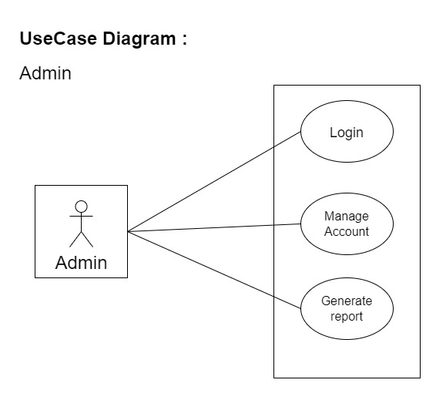

*Fig. Use case diagram for admin*

1. In Admin use case diagram Admin is the Actor.
2. Admin can handle following use cases:
3. Login
4. Report Generation
5. Controls account

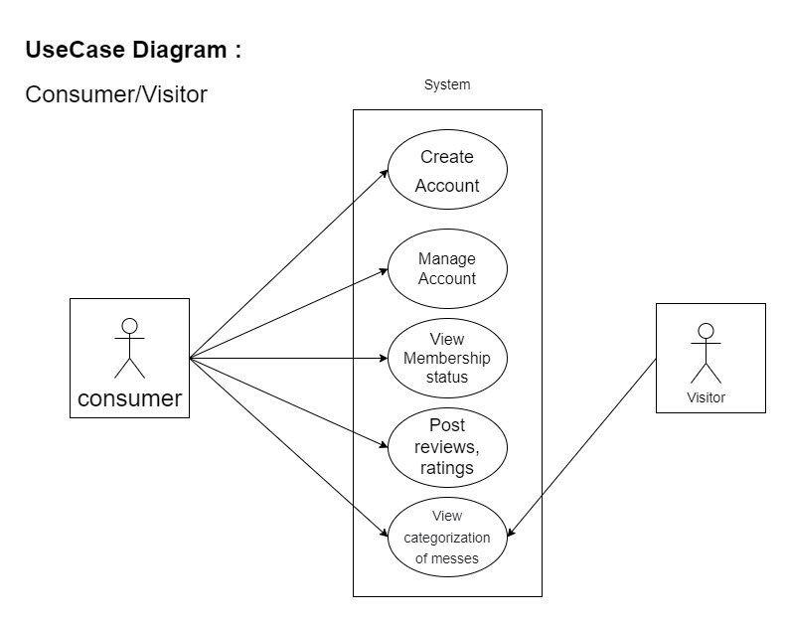

*Fig. Use case diagram for consumer/visitor*

**Consumer:**

1. In Consumer use case diagram Consumer is the Actor.
2. Consumer can handle following use cases:
3. Register
4. Login
5. Search Messes
6. Give Reviews and ratings
7. Manage profile
8. View Membership status

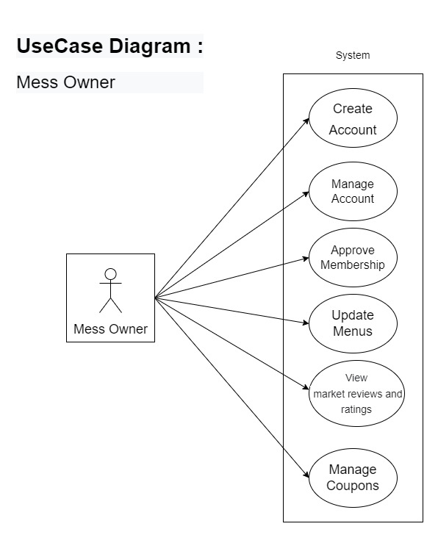**Mess Owner:**

*Fig. Use case diagram for Mess Owners*

1. In Mess owner use case diagram Mess Owner is the Actor**.**
2. Mess owner can handle following use cases:
3. Register itself with admins approval
4. Login /profile management
5. View market
6. Update Menu
7. Manage Discount coupons
8. 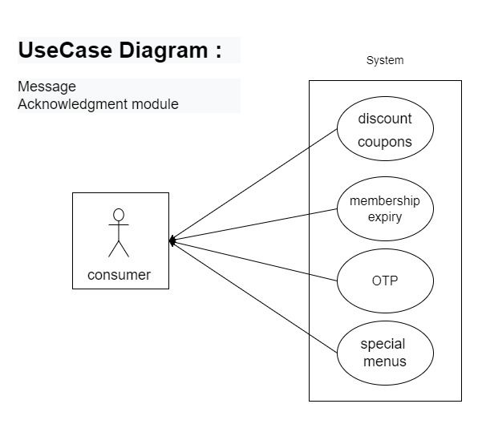Approve Memberships of consumers
9. Message Acknowledgement perform following use cases:
10. Notify special menus
11. Notify discount coupons
12. Notify OTP
13. Notify membership expiry